VPC USING NAT Gateway with correct steps
- VPC with Bastion Server
VPC & Subnet Design
VPC CIDR: 10.0.0.0/16
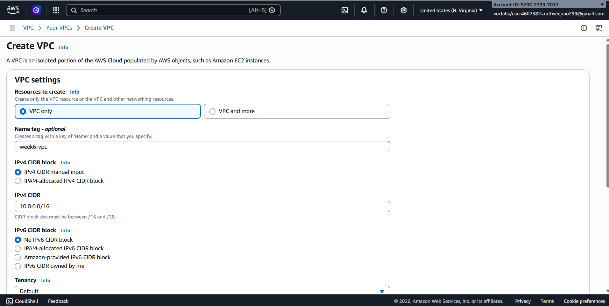
Public Subnet (Bastion Server): 10.0.1.0/24
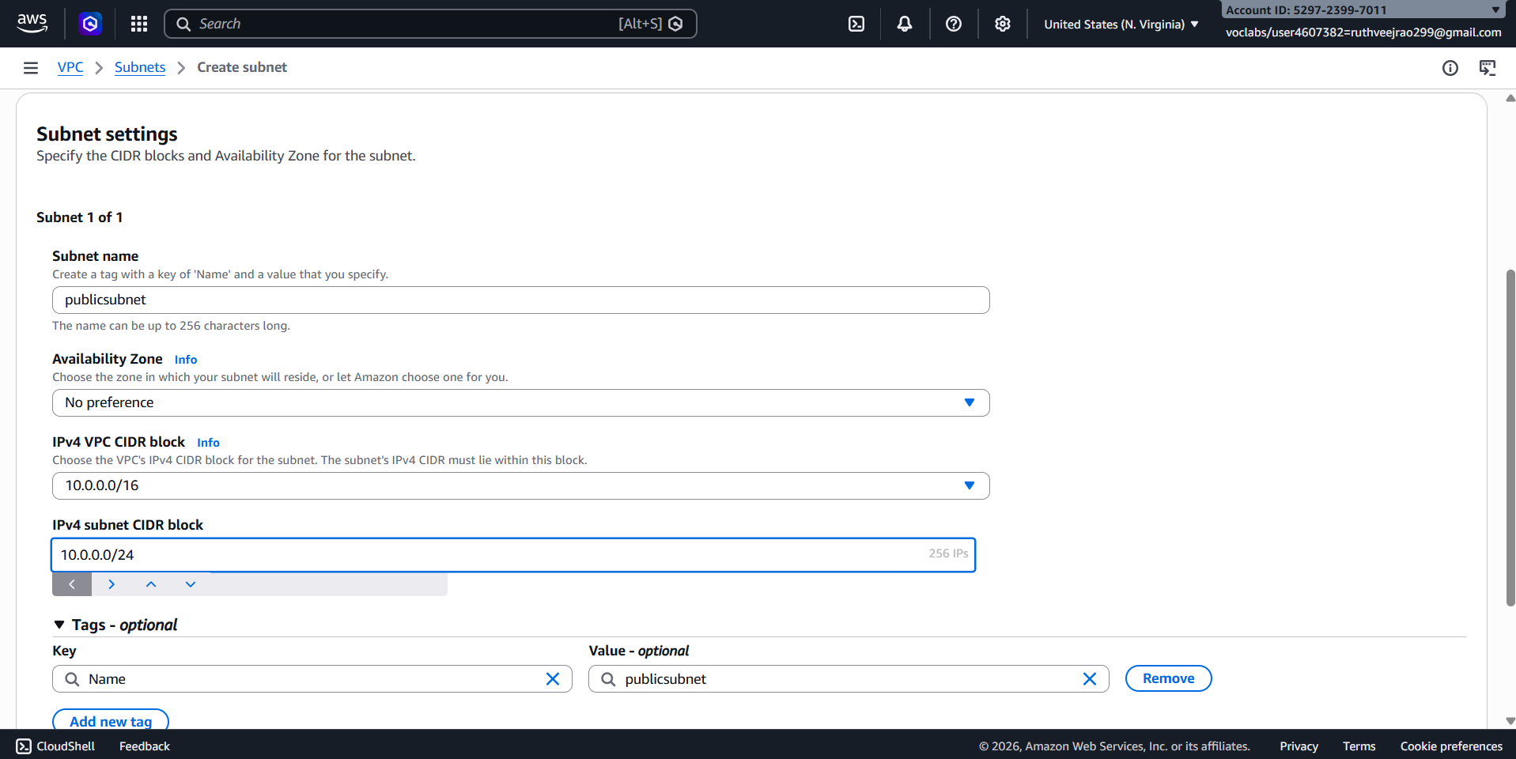
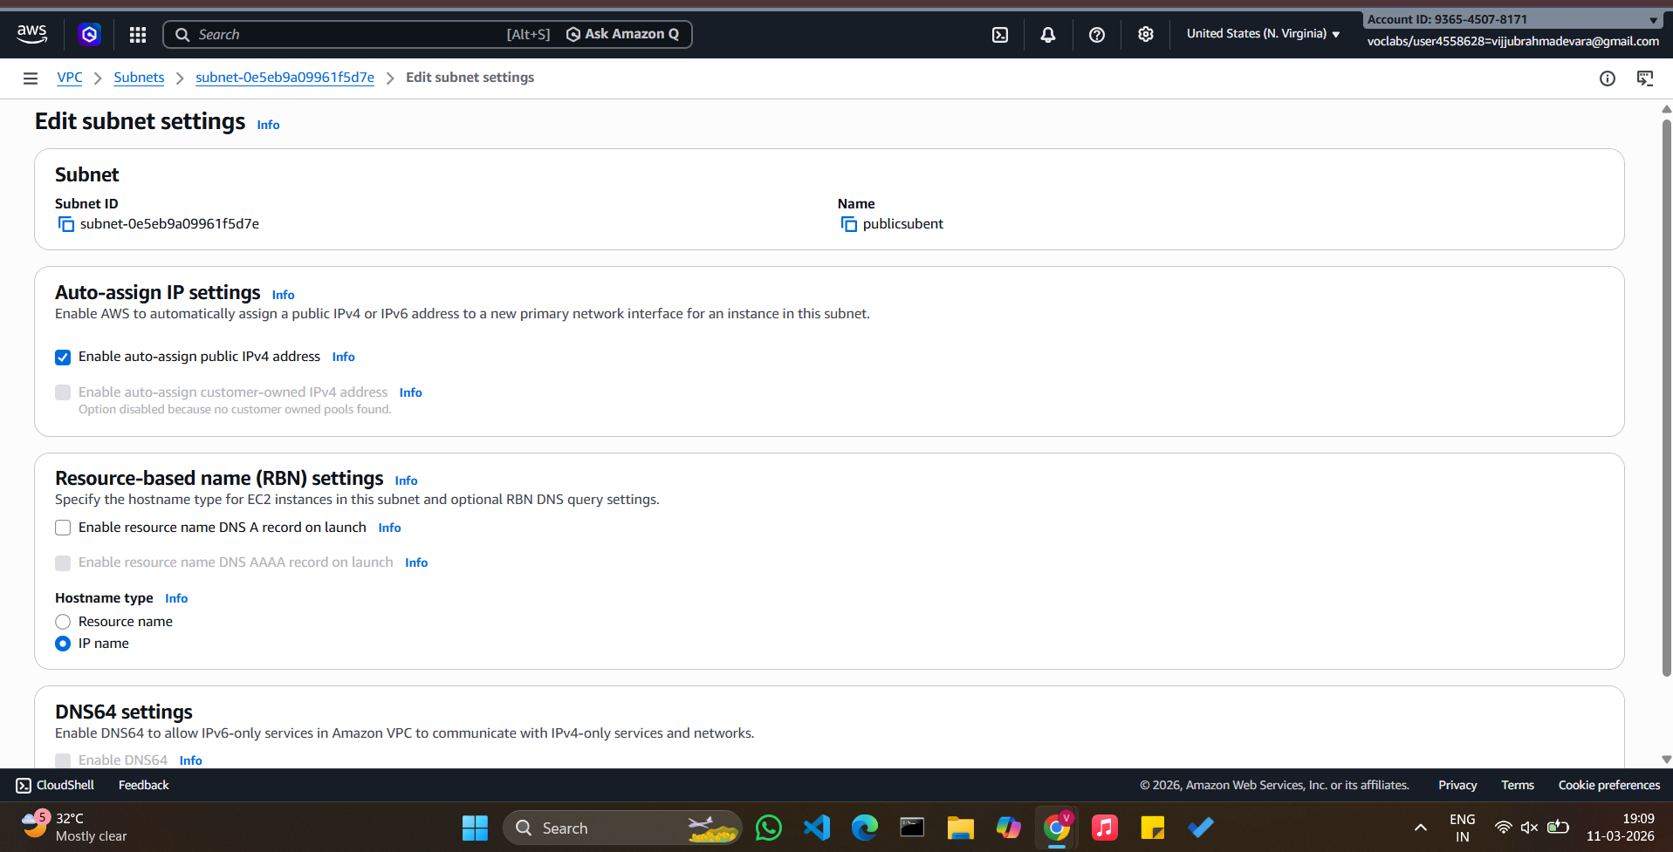
Private Subnet (Database Server): 10.0.2.0/24
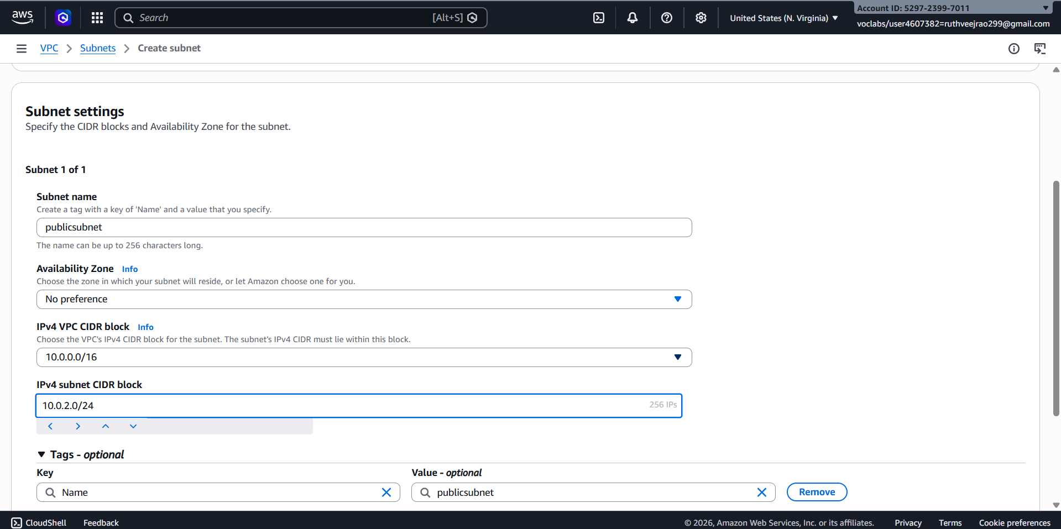

- Create Internet gateway
Attach week-6VPC
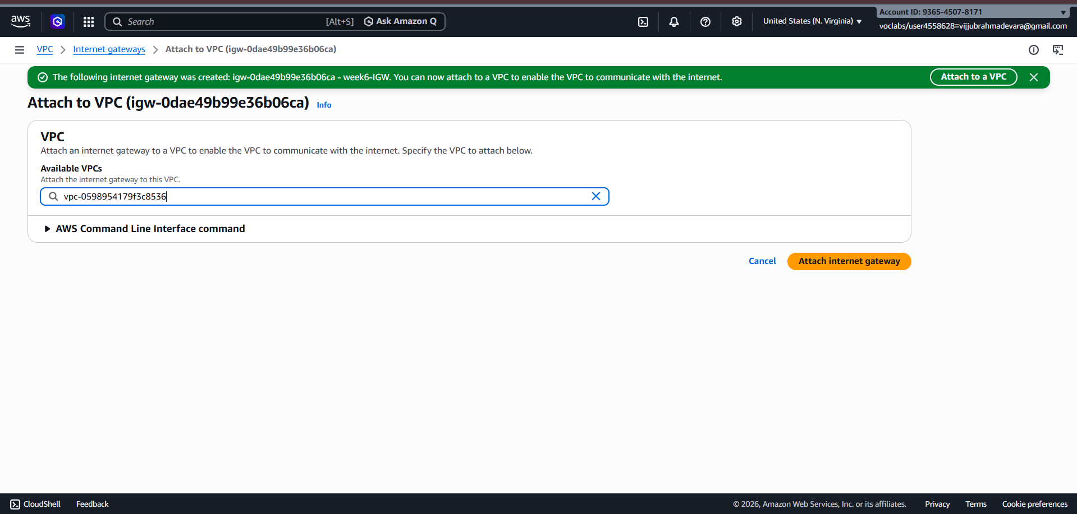
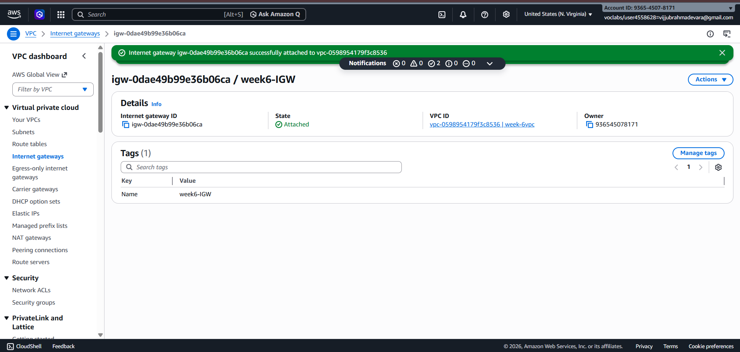
- Create Nategateway
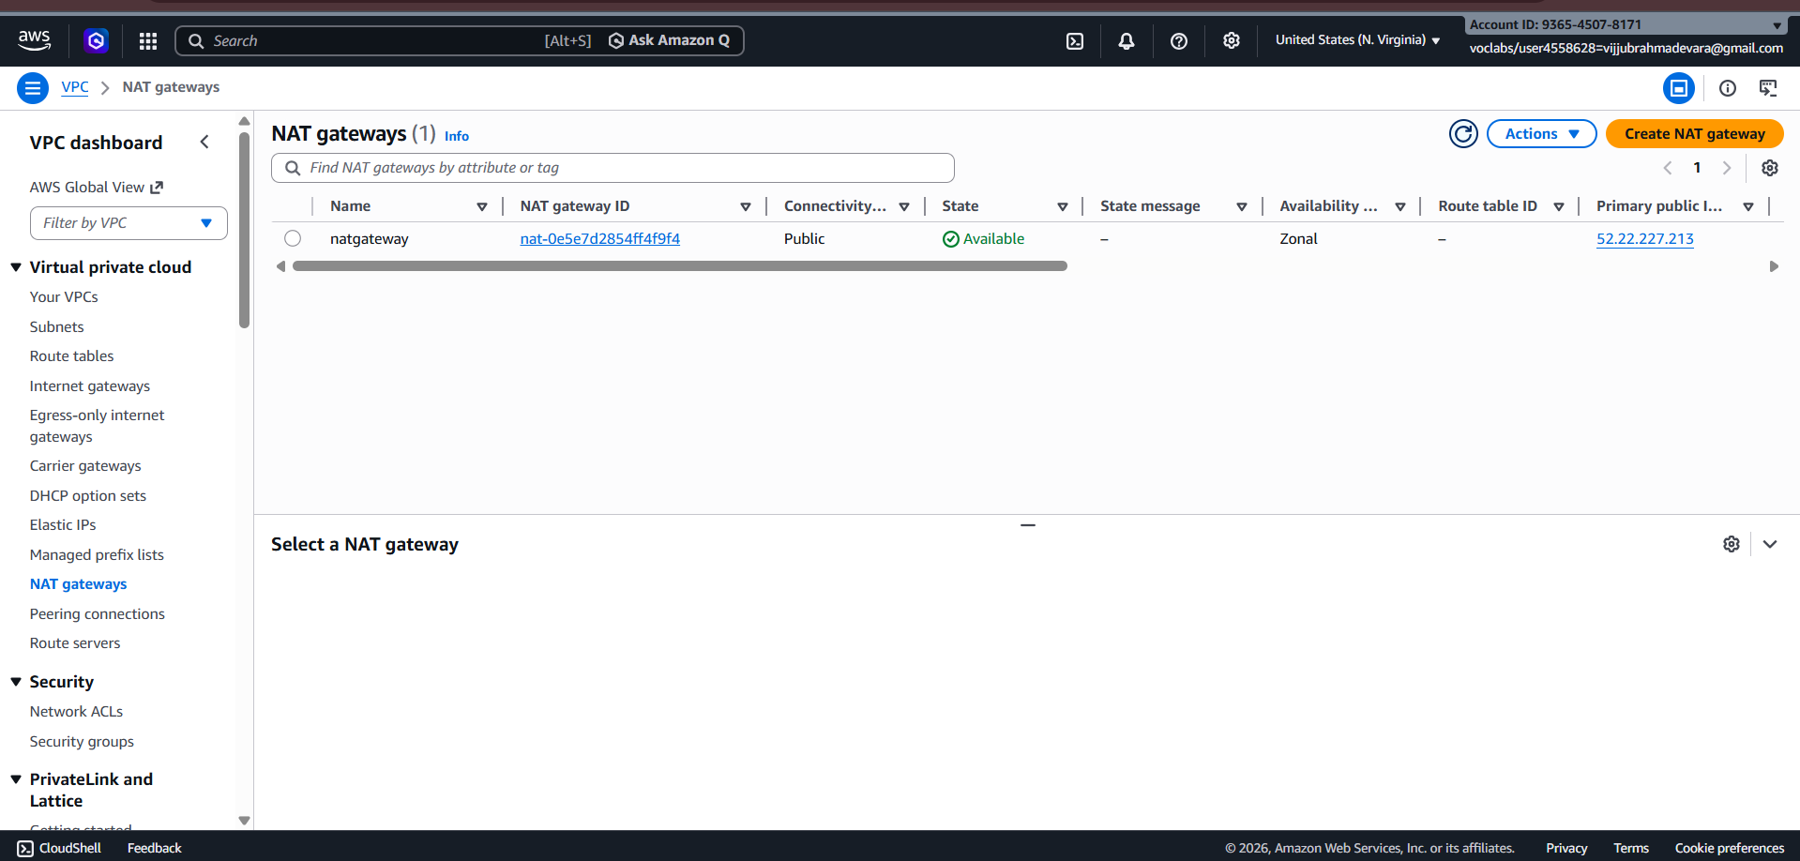
- Create Route Tables
- Create RoutetablePublic
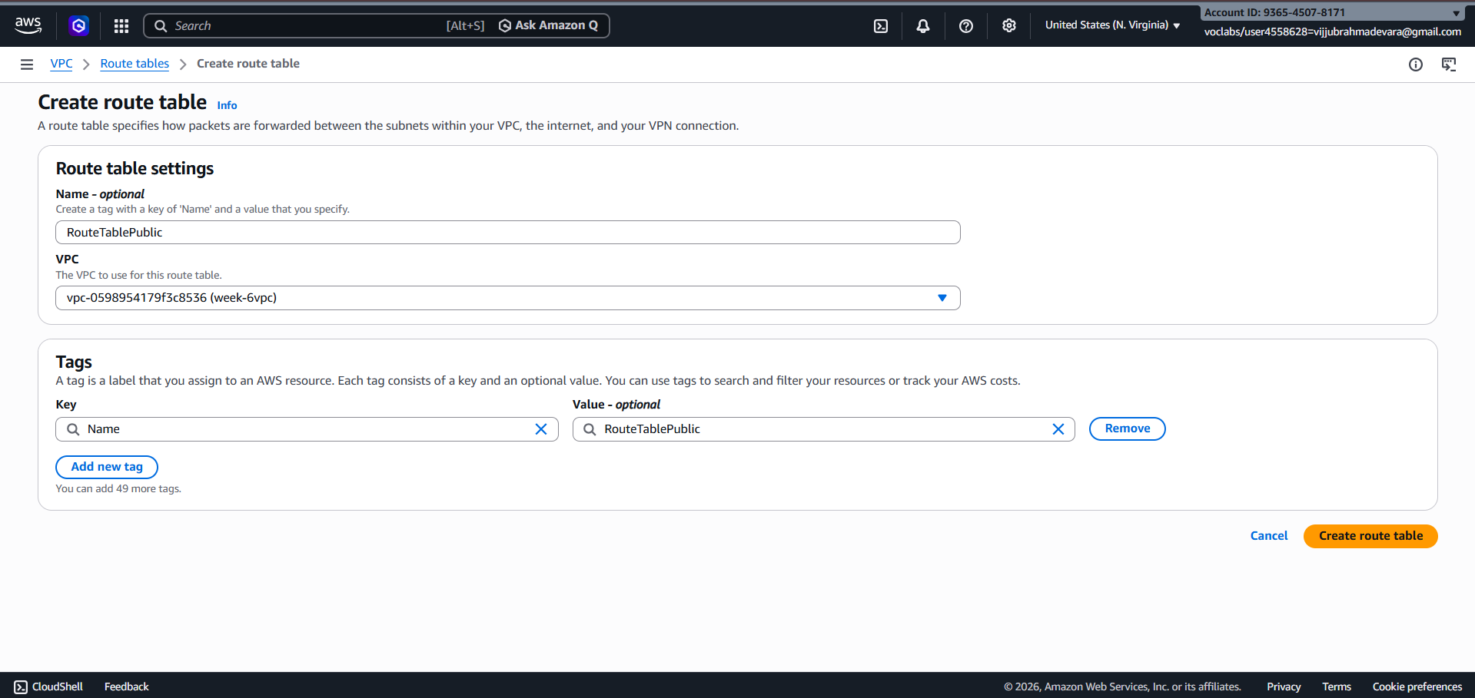
- Attach Public Subnet
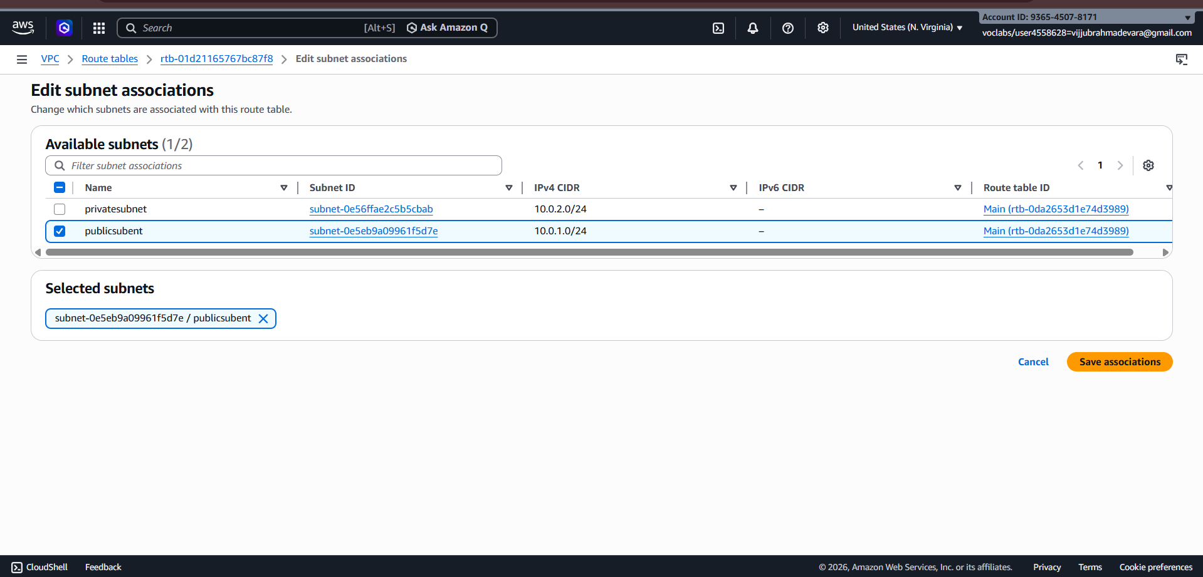
- Edit Route: Attach internet gateway
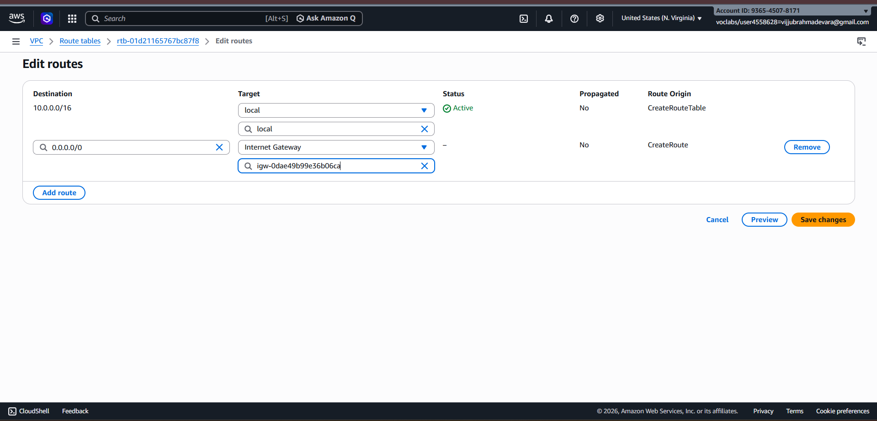
- Create RouteTablePrivate
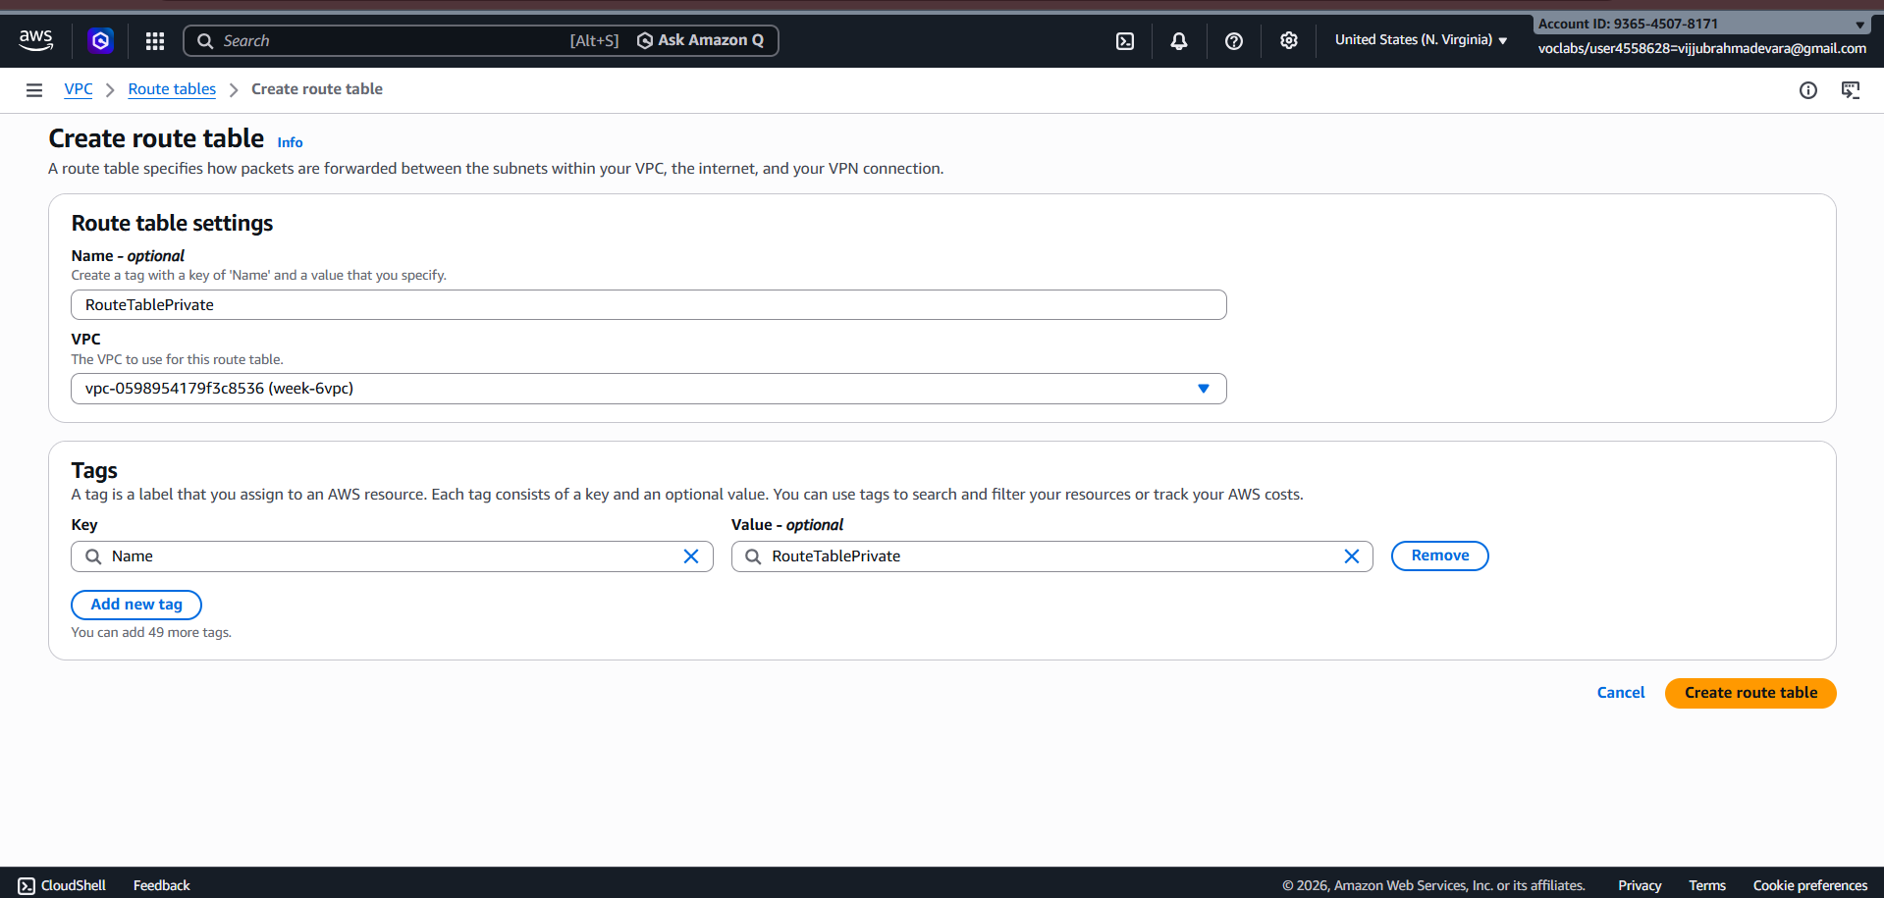
- Attach Private Subnet
- Edit Route (Add route: Destination :0.0.0.0/0 Target :Nat gateway)
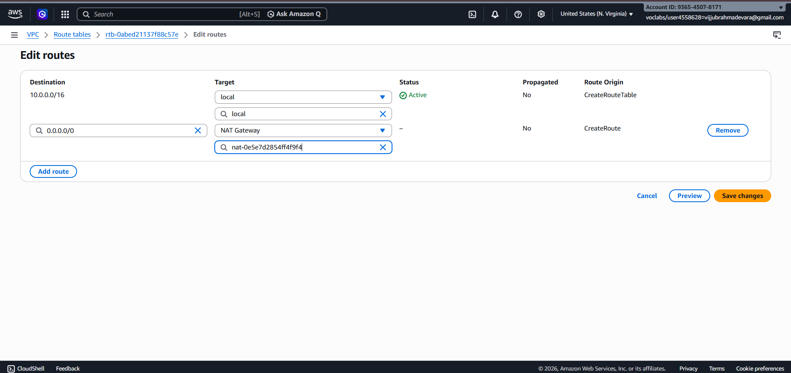

- EC2 Instance Creation
Create Database Server Instance - PrivteDBserver-EC2
Subnet: Private Subnet (10.0.2.0/24)
Key pair: dbserver.pem
Operating System: Ubuntu
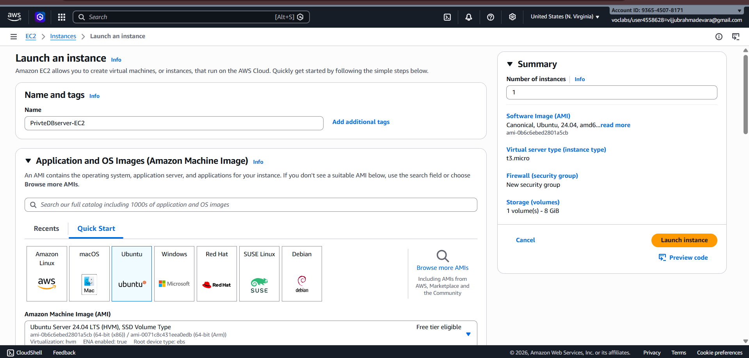
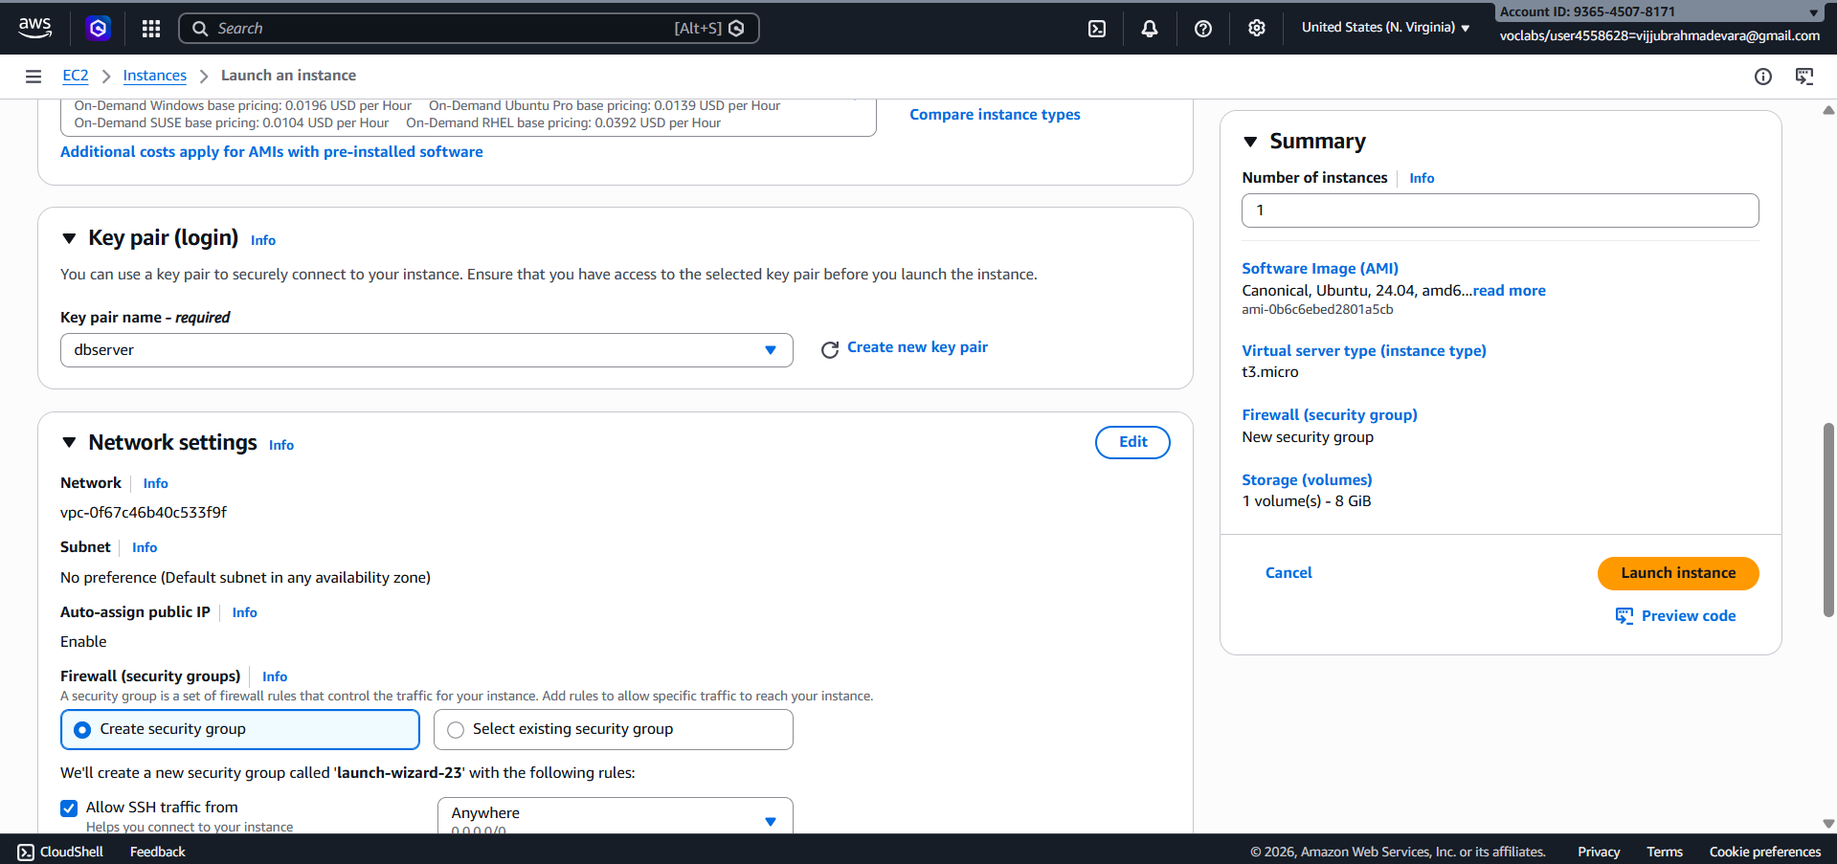

click on Edit near Network Settings
- VPC- week-6VPC
- Subnet : PrivateDBserver-EC2
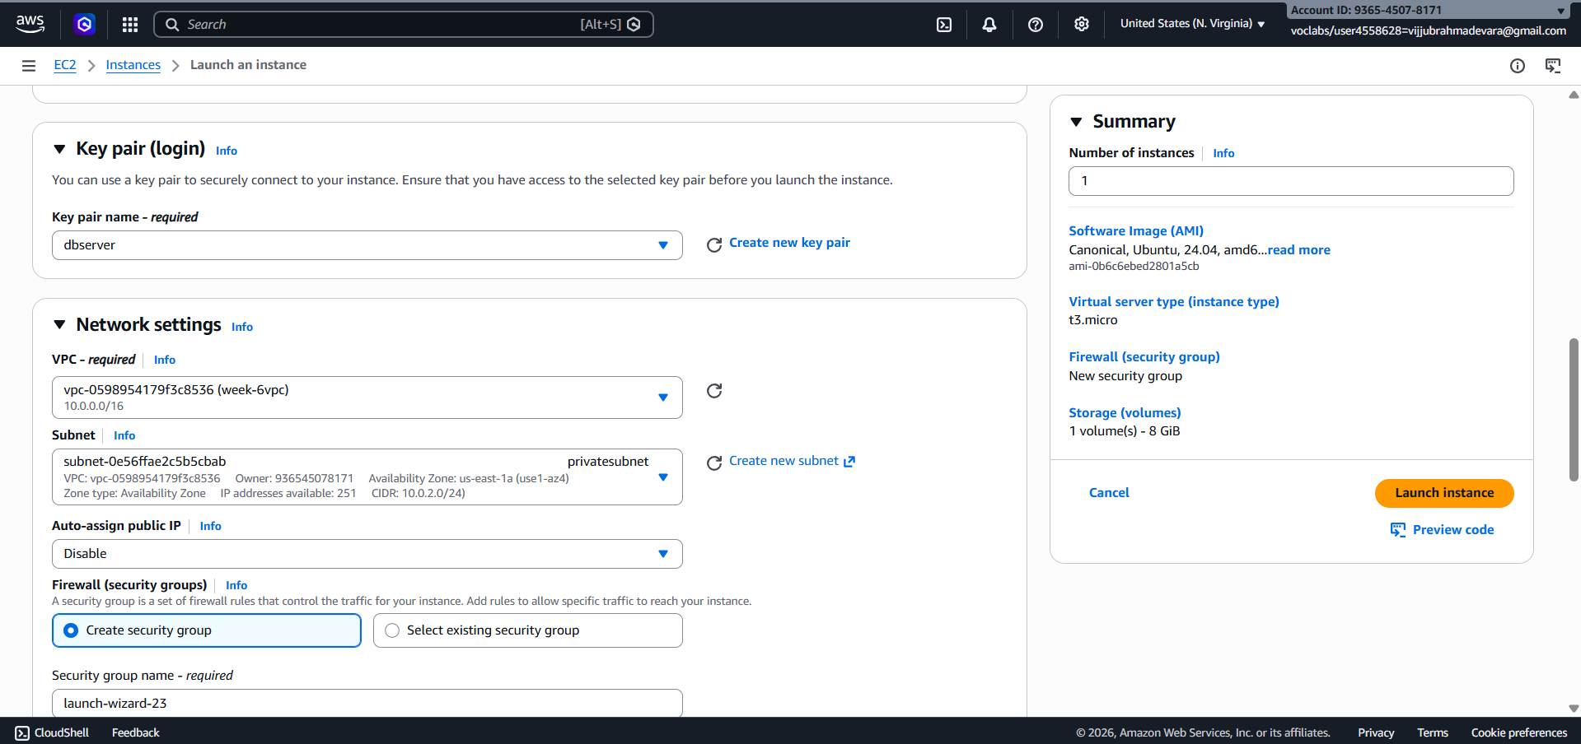
- Add security rule :
SSH default
Type- MySQL/Aurora Source- My IP
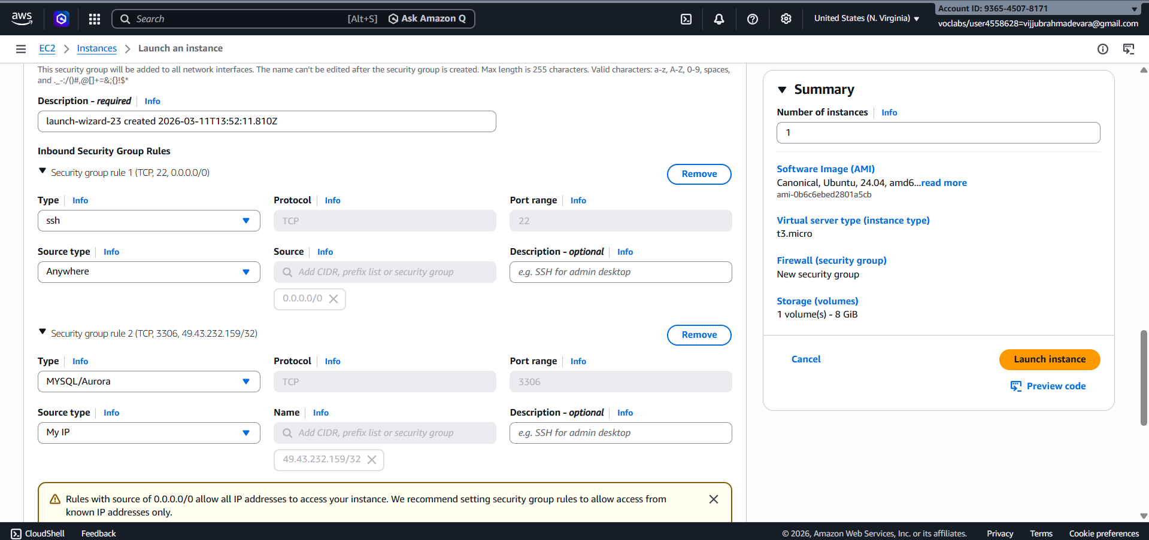
Create Bastion Server Database Server Instance- Public-BServer-EC2
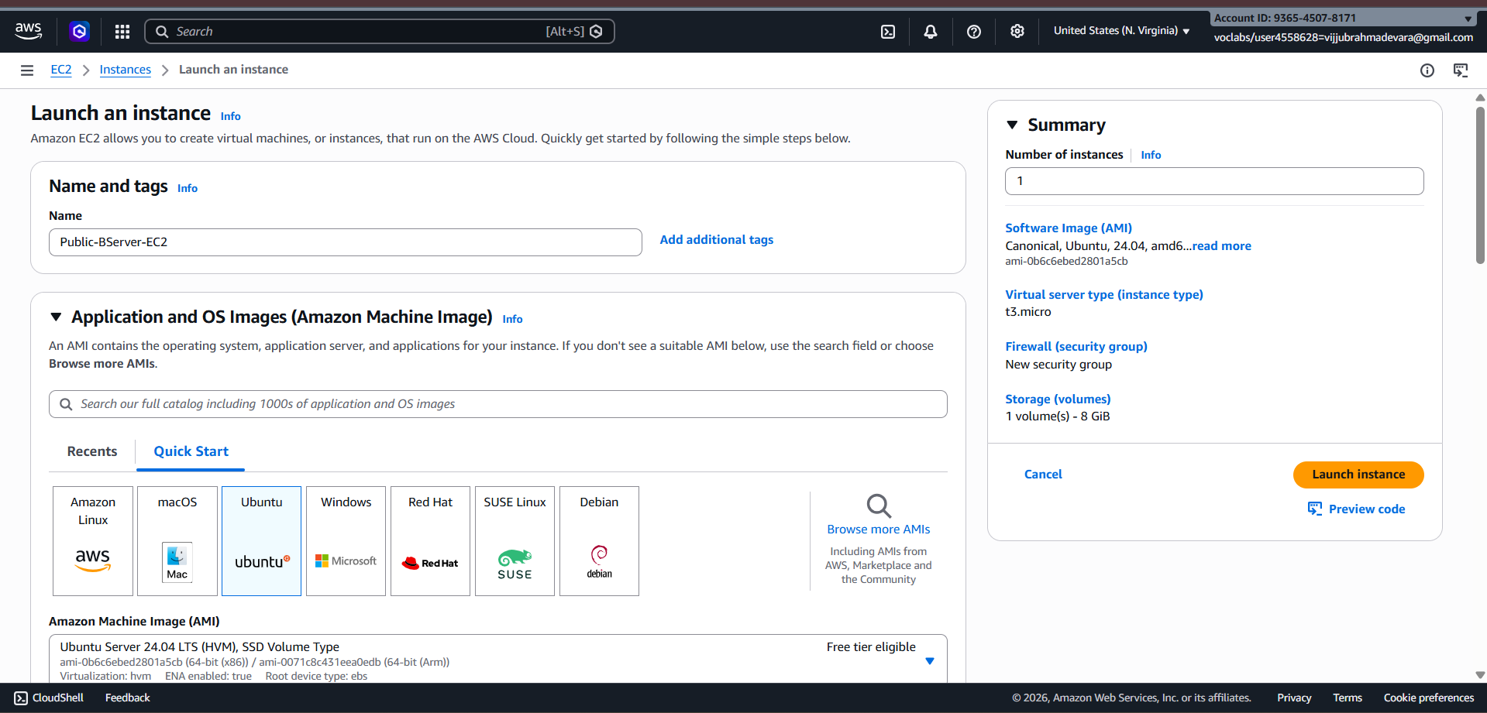
VPC- week-6VPC
Operating System: Ubuntu
Key pair: bastion.pem

Subnet: Public Subnet (10.0.1.0/24) –PublicBastionserver-EC2
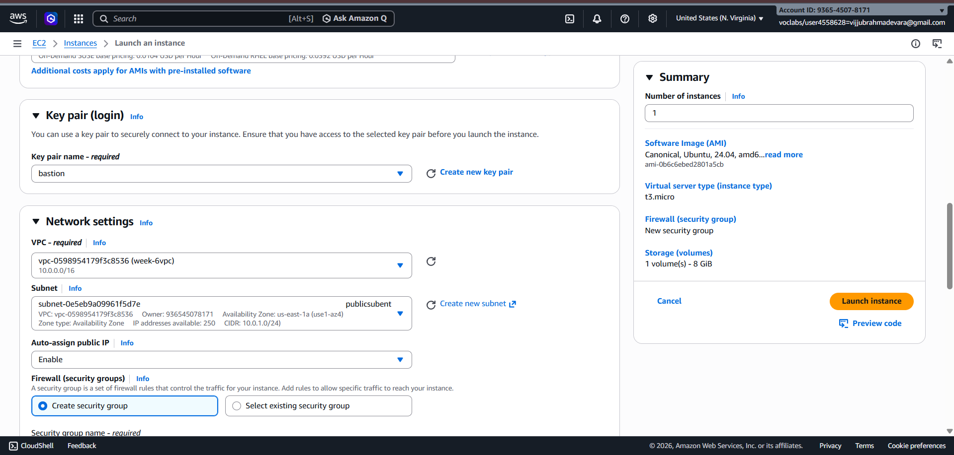
Add security rule :
SSH default

Type- MySQL/Aurora Source- Private Instance IP (PrivteDBserver-EC2)

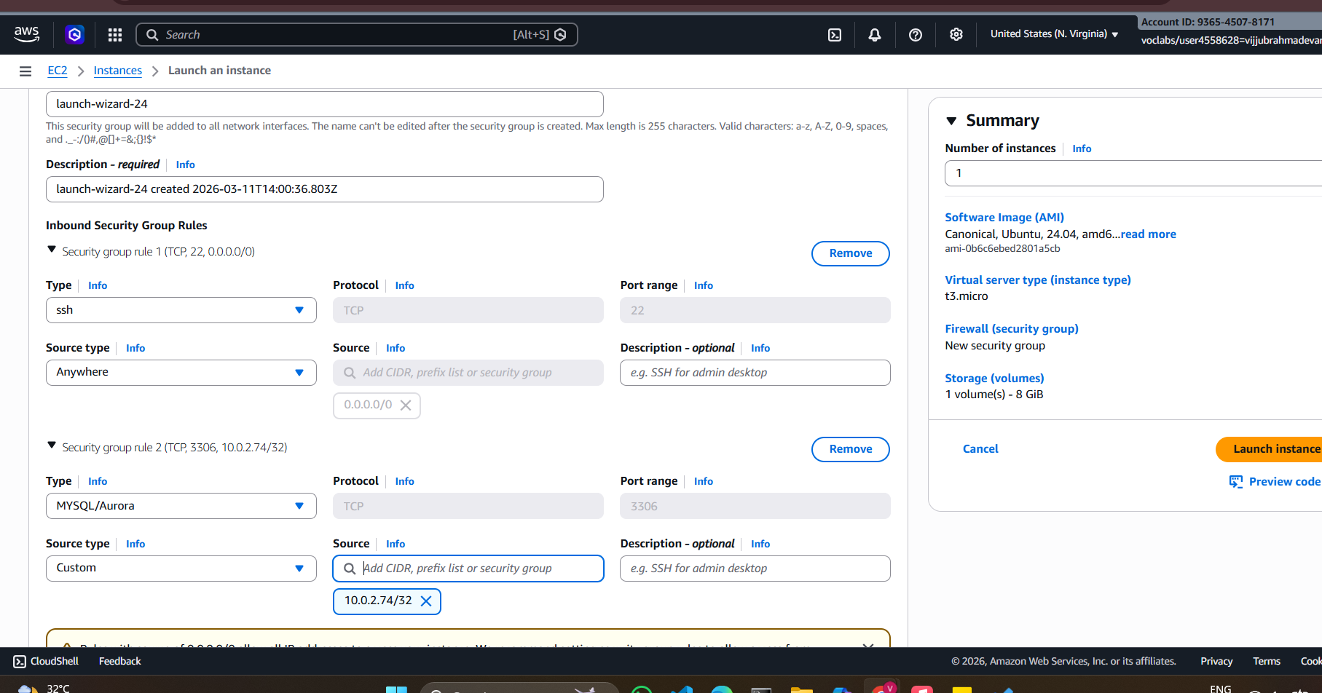

- Open powershell or go to Downloads and open Git Bash here( Git Bash choosen)
Copy DB Server Key to Bastion Server
Because: ( Database server is in private subnet. Direct SSH from local system is NOT
possible. DB server key must be copied to Bastion server)
First copy Public Bastion Instance Public IP address and paste in scp command

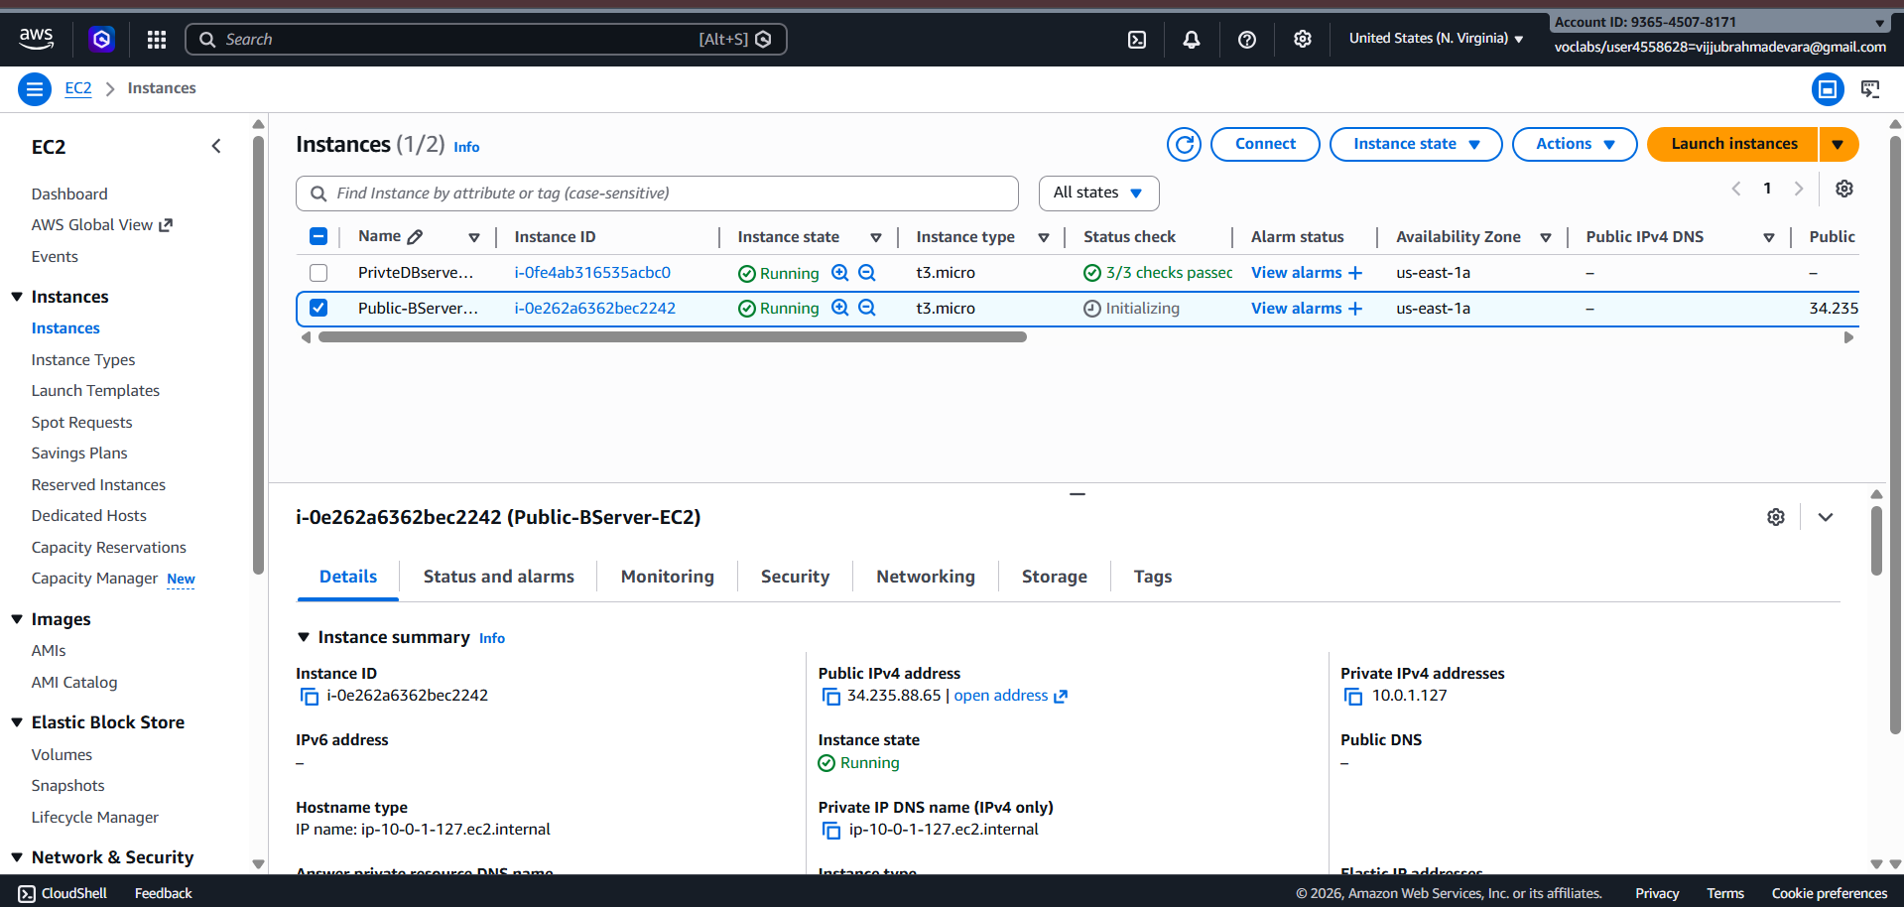

Command (PowerShell / Git Bash):
Set the path : > cd /c/Users/"BHARGAVI KUMBHAM"/Downloads
scp -i bastion.pem dbserver.pem ubuntu@ <BASTION_PUBLIC_IP>:/home/ubuntu/
example: scp -i bserver.pem dbserver.pem ubuntu@34.224.223.138:/home/ubuntu/
Copy file → to remote server → inside /home/ubuntu directory

File is copied securely using SCP
dbserver.pem will now be available inside Bastion server

- Connect to Bastion Server
SSH Command:
ssh -i bserver.pem ubuntu@34.224.223.138
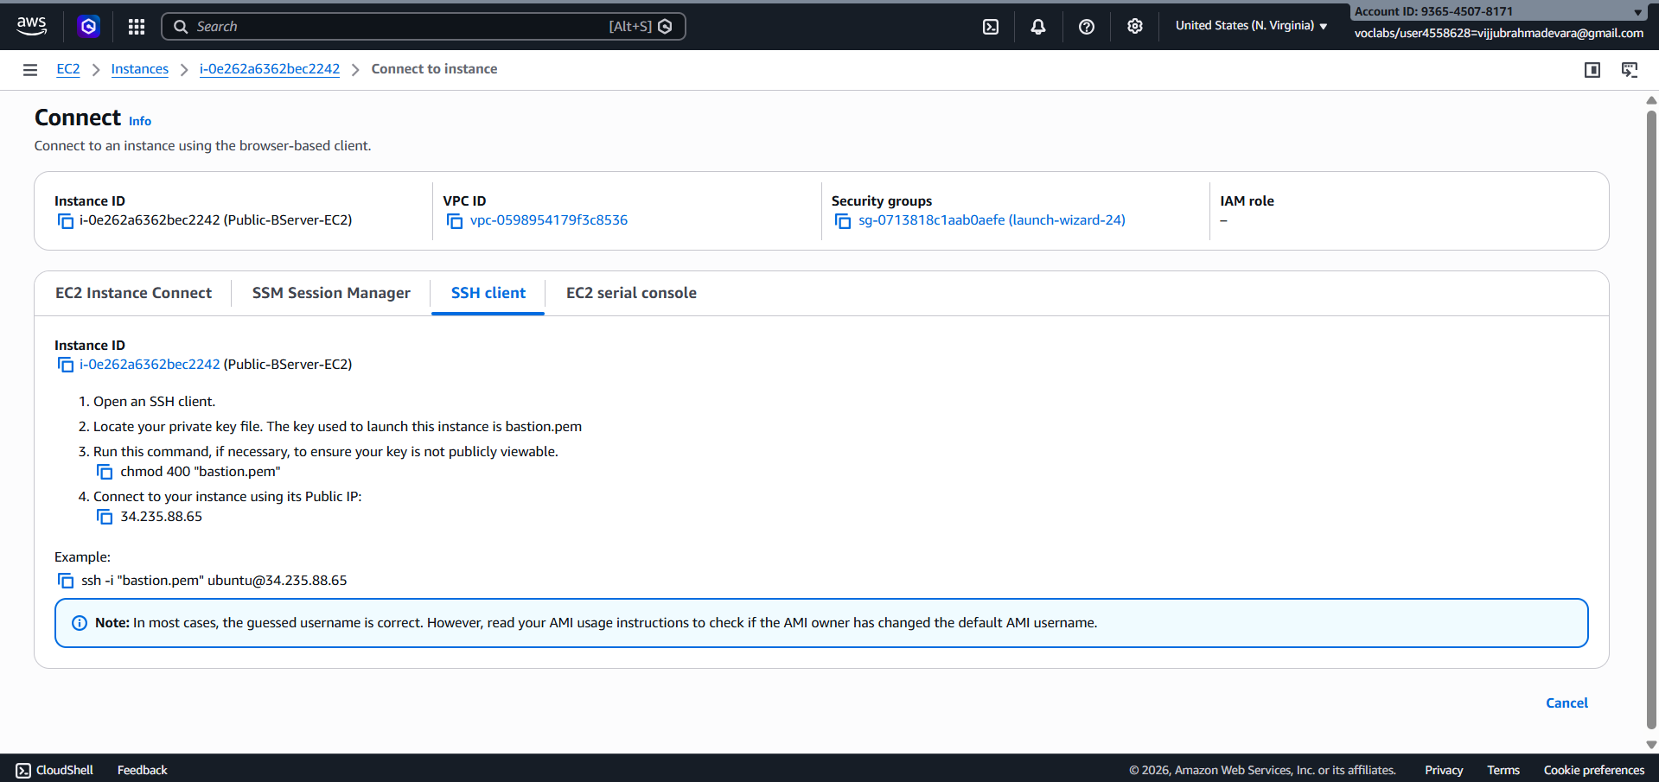
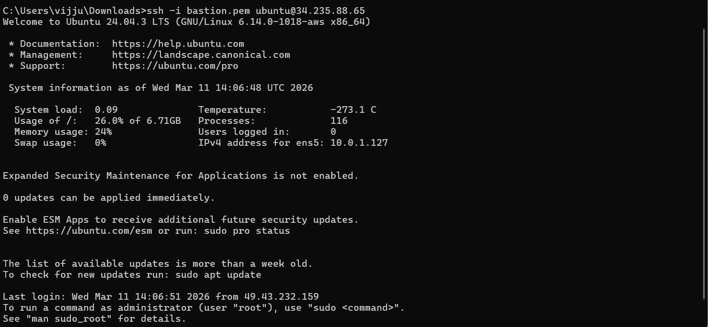

eg: ssh -i "bastion.pem" ubuntu@3.239.225.180

Above shows ubuntu running on public instance (at 10.0.1.252)
Verify key files:
ls
Output:
dbserver.pem

- Connect from Bastion to Database Server
- First execute in Git bash command (Important)
chmod 400 dbserver.pem
- Copy SSH of Dbserver:
ssh -i "dbserver.pem" ubuntu@10.0.2.220

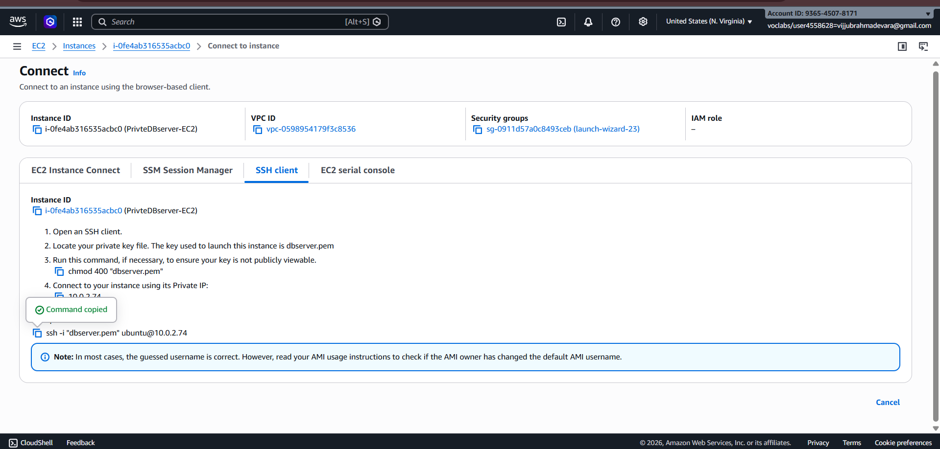
- Now SSH it from Bastion ie paste above copied SSH of dbserver into Git bash prompt.

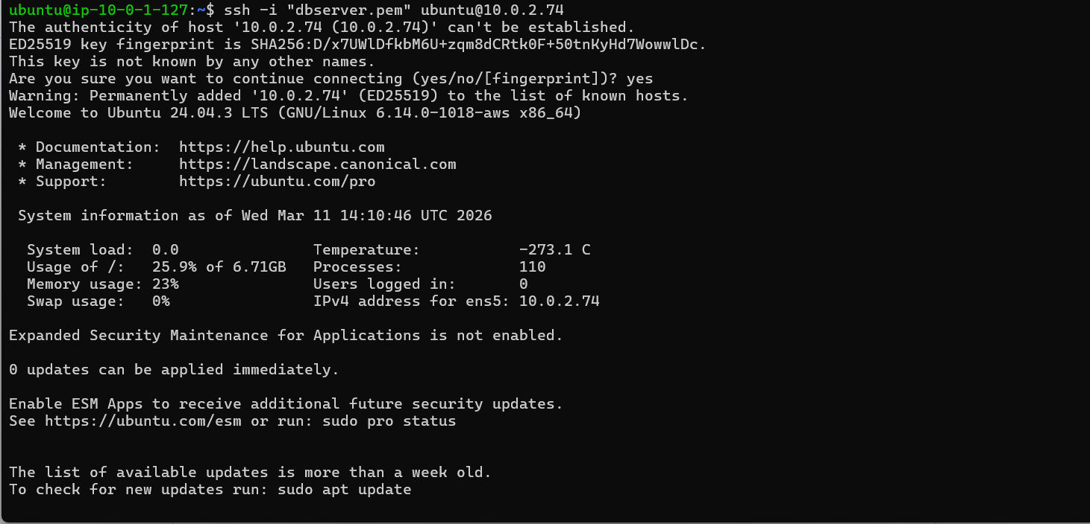

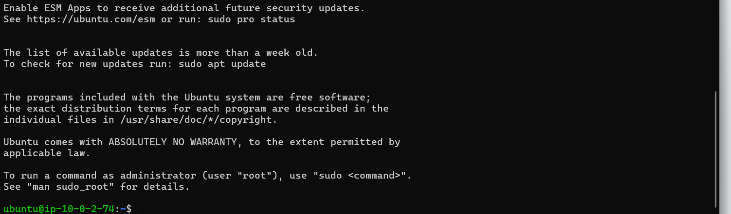
Connection to DB server is successful and ubuntu is now running from dbserver at 10.0.7.235
Logout from connection
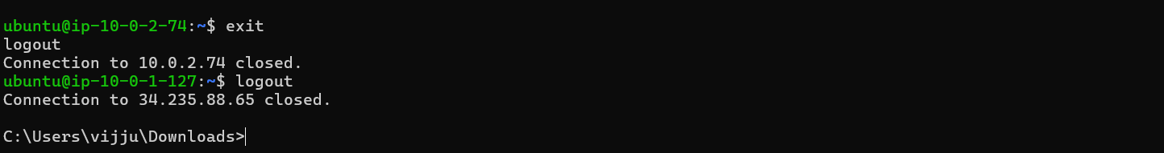

Terminate, delete, detach all.
Nat gateway delete (otherwise it cost).
Stop AWS

SCENARIO BASED QUESTIONS

Q1. You have multiple private subnets in different AZs. Should you use one NAT Gateway or multiple NAT Gateways? Explain your design choice.
Answer: Use multiple NAT Gateways, one per Availability Zone. This ensures high availability and prevents cross-AZ data transfer costs. Each private subnet should route traffic to the NAT Gateway in the same AZ.
Q2. Your private subnet instances can reach the internet, but the NAT Gateway shows no traffic. What could be the possible reasons?
Answer: The route table might be pointing to a different NAT Gateway or an Internet Gateway. Instances could be using VPC endpoints instead of NAT. Another possibility is that the subnet is associated with the wrong route table.
Q3. A NAT Gateway was accidentally created in a private subnet instead of a public subnet. What problem will occur, and how would you fix it?
Answer: The NAT Gateway will not have internet access because private subnets do not route to an Internet Gateway. As a result, private instances cannot access external services. Fix this by creating the NAT Gateway in a public subnet with proper routing.
Q4. An application running in a private subnet requires outbound access only to a few trusted external services. How would you restrict traffic while still using a NAT Gateway?
Answer: Configure security groups or network ACLs to allow traffic only to specific destination IPs. You can also implement filtering using a proxy or AWS Network Firewall. This limits access to only trusted services.
Q5. Multiple teams share a single VPC and NAT Gateway. One team’s traffic is affecting others. How would you redesign the NAT Gateway setup to isolate traffic?
Answer: Create separate NAT Gateways for different teams or subnets. Assign individual route tables so each team routes through its own NAT Gateway. This isolates traffic and improves performance.
Q6. You can successfully SSH into a private EC2 instance using a Bastion server, but yum update / apt update fails inside the private instance. Why?
Answer: The private subnet may not have a route to the NAT Gateway. The NAT Gateway might be misconfigured or missing an Elastic IP. Without proper NAT routing, the instance cannot access the internet.
Q7. Private EC2 instances can access the internet through a NAT Gateway, but administrators cannot SSH into them using the Bastion server.
Answer: The security group of the private instance may not allow SSH access from the Bastion server. There could also be an incorrect private IP or a network ACL blocking port 22. Ensure SSH is allowed from the Bastion host.
Q8. A Bastion server and NAT Gateway are both created in a private subnet by mistake. What impact does this cause?
Answer: The Bastion server will not be accessible from the internet because it lacks a public IP. The NAT Gateway will also fail to provide outbound internet access. Both must be placed in a public subnet.
Q9. SSH access to the Bastion server works, but SSH from Bastion to the private EC2 fails. Why?
Answer: The private instance security group may not allow SSH from the Bastion server. There may also be routing or network ACL issues blocking port 22. Verify that SSH access is permitted from the Bastion server.
Q10. A student claims that a Bastion server alone is enough to provide internet access to private instances. Why is Bastion not a replacement for NAT Gateway?
Answer: A Bastion server is used only for secure administrative access via SSH. It does not handle outbound internet traffic for instances. A NAT Gateway is required to enable private instances to access external networks.

